Game Concept:

* Top-Down Sidescroller
  + 2D Auto-Sidescroller where you navigate through obstacles, put out fire with your hose and save civilians, all whilst getting out yourself
  + Maze: Must navigate through collapsed building and fire
  + 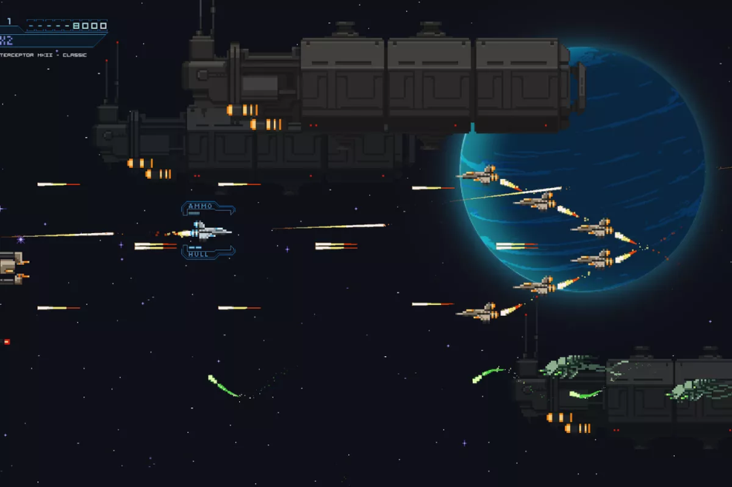

   --------------------------------------------------------------------------------------------------------------------------------

@ O O A O

@ O O F O A

@ O O F A A

@ O O F F A A A

@ F O A A A O   
@ S F C O O A O

@ F C O   
@ O O A FFFFFFFFFFFF

@ O O A A FFFF C      F F   
@ O O A F FFFF C      F F

@ O O C A A FFFFFFFFFFFF

-------------------------------------------------------------------------------------------------------------------------------

LEGEND:

S = Start-point (Will vary)

C = Civilians needed to save (Objective of the game)

O = Obstacles

A = Can Jump over

F = Fires (Obstacles needed to be avoided or removed to reach civilians

* Color change in Fire
* Fire Boss (with AI)
* Endless level
* Multiplayer
* Inventory for diff guns
* Changeable controls
* Display high score
* Settings
* Difficulty level
* Cheat codes

BGM plays in splash screen

SFX only in gameplay

Task Allocations:

* Matthew
  + Auto scroll
  + Collisions
* Qing Bing
  + ASCII Art
* Liu Hao
  + Sound effects
  + Exit, pause, play and retry
* Guan Yu
  + Player movement
  + Multiple Levels
  + Pause